Dev Ops Lab1

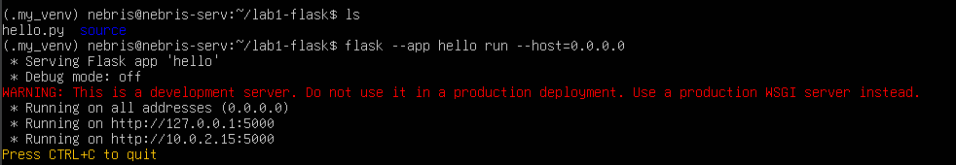
Flask App running on CLI

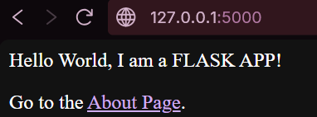
Flask App running on webpage through OperaGX -> Home Page

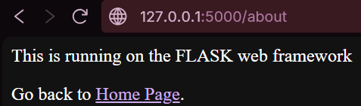
Flask App running on webpage through OperaGX -> About Page

Python Code

from flask import Flask

app = Flask(__name__)

@app.route('/')
def hello():
return '''
<p>Hello world, I am a FLASK APP!</p>
<p>Go to the <a href="/about">About Page</a>.</p>
'''

@app.route('/about')
def about():
return '''
<p>This is the About Page.</p>
<p>Go back to the <a href="/">Home Page</a>.</p>
'''

if __name__ == '__main__':
app.run(host='0.0.0.0', port=5000)

Shell Script Code

#!/bin/bash

# Update and Upgrade the system
sudo apt update -y && sudo apt upgrade -y

# Install Python3 and pip
sudo apt install -y nano vim python-is-python3 \ python3-pip
sudo apt install -y nano vim python3 \ python3-venv

# Create and activate a virtual environment
python -m venv.my_venv
source .my_venv/bin/activate

# Install Flask
sudo apt install python3-flask

# Run a simple Flask app (make sure hello.py exists in the same directory)
flask --app hello run --host=0.0.0.0

